**ACTIVITY LIFE CYCLE OF ANDROID**

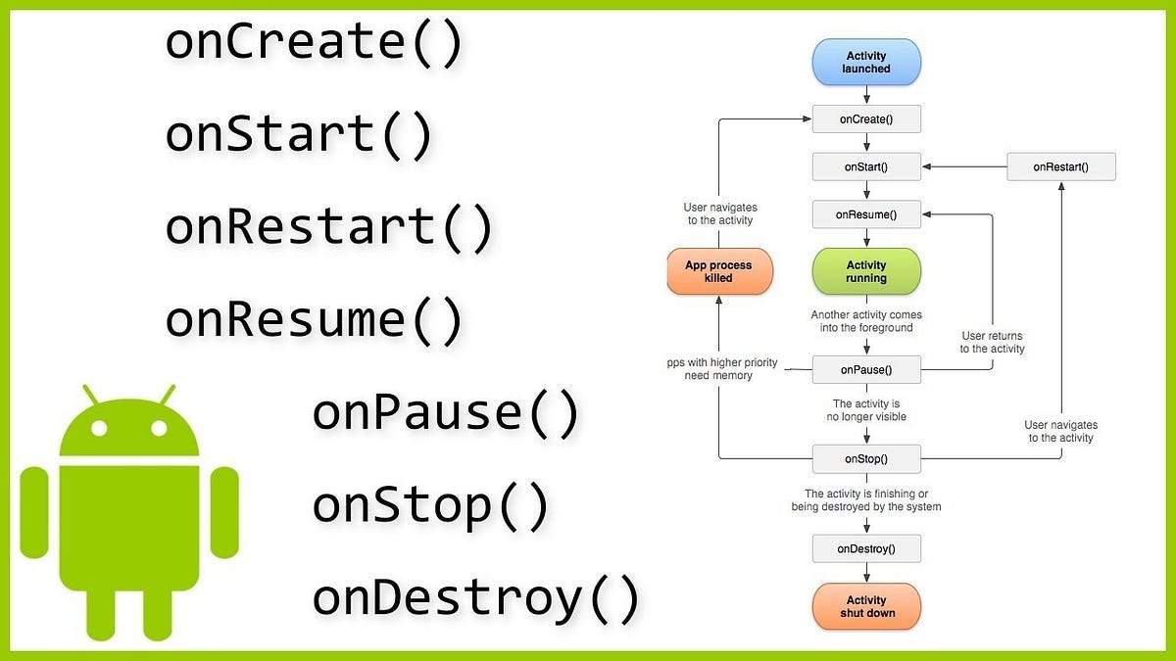

1. onCreate: Called when the Activity is first created. Used for initialization.
2. onStart: Called when the Activity becomes visible but not yet interactive.
3. onResume: Called when the Activity is in the foreground and ready for user interaction.
4. onPause: Called when the Activity is partially visible (e.g., another Activity appears in the foreground).
5. onStop: Called when the Activity is no longer visible to the user.
6. onRestart: Called after onStop, just before onStart, when the Activity is being restarted.
7. onDestroy: Called when the Activity is about to be destroyed**.**
8. **MainActivity.java**

package com.example.lifecycleexample;

import androidx.appcompat.app.AppCompatActivity;

import android.os.Bundle;

import android.util.Log;

public class MainActivity extends AppCompatActivity {

private static final String TAG = "ActivityLifecycle";

@Override

protected void onCreate(Bundle savedInstanceState) {

super.onCreate(savedInstanceState);

setContentView(R.layout.activity_main);

Log.d(TAG, "onCreate: Activity is created.");

}

@Override

protected void onStart() {

super.onStart();

Log.d(TAG, "onStart: Activity is visible to the user.");

}

@Override

protected void onResume() {

super.onResume();

Log.d(TAG, "onResume: Activity is now interactive.");

}

@Override

protected void onPause() {

super.onPause();

Log.d(TAG, "onPause: Activity is partially visible.");

}

@Override

protected void onStop() {

super.onStop();

Log.d(TAG, "onStop: Activity is no longer visible.");

}

@Override

protected void onRestart() {

super.onRestart();

Log.d(TAG, "onRestart: Activity is restarting.");

}

@Override

protected void onDestroy() {

super.onDestroy();

Log.d(TAG, "onDestroy: Activity is about to be destroyed.");

}

}

**activity_main.xml**

<?xml version="1.0" encoding="utf-8"?>

<LinearLayout

xmlns:android="http://schemas.android.com/apk/res/android"

android:layout_width="match_parent"

android:layout_height="match_parent"

android:orientation="vertical"

android:gravity="center">

<TextView

android:layout_width="wrap_content"

android:layout_height="wrap_content"

android:text="Lifecycle Demo"

android:textSize="20sp"

android:padding="16dp" />

</LinearLayout>